Case Study – 05

Title / Aim :- To study the functioning of Arrays and Loops in JavaScript
- Create and manipulate arrays using `push()`, `pop()`, `shift()`, `unshift()`, `splice()`, and `slice()`.
- Use array methods `map()`, `filter()`, `reduce()`, and `forEach()`.
- Case Study: Create an array of numbers and find the maximum and minimum values.
Software/Tools Required :-
- Visual Studio Code (VS Code)
- Google Chrome / Any Web Browser
- HTML
- JavaScript

CODE :-
Index.html
<!DOCTYPE html>
<html lang="en">
<head>
<meta charset="UTF-8">
<meta name="viewport" content="width=device-width, initial-scale=1.0">
<title>Cricket Player Statistics</title>
<link rel="stylesheet" href="style.css">
</head>

<body>

<div class="container">

<header>
<h1>🏏 Cricket Player Statistics</h1>
<p>Explore Player Performance Using JavaScript Arrays</p>
</header>

<!-- Player List -->
<section class="card">

<h2>🏆 Player Scores</h2>

<div id="playerList" class="players"></div>

</section>

<!-- Array Operations -->
<section class="card">

<h2>🔧 Array Operations</h2>

<div class="buttons">

<button onclick="addPlayer()">Push Player</button>

<button onclick="removeLastPlayer()">Pop Player</button>

<button onclick="removeFirstPlayer()">Shift Player</button>

<button onclick="addFirstPlayer()">Unshift Player</button>

<button onclick="replacePlayer()">Splice Player</button>

<button onclick="showSlice()">Slice Players</button>

<button onclick="resetPlayers()">Reset</button>

</div>

<div id="operationResult" class="result">
Select an operation
</div>

</section>

<!-- Array Methods -->
<section class="card">

<h2>📊 Array Methods</h2>

<div class="buttons">

<button onclick="useMap()">map()</button>

<button onclick="useFilter()">filter()</button>

<button onclick="useReduce()">reduce()</button>

<button onclick="useForEach()">forEach()</button>

</div>

<div id="methodResult" class="result">
Select an array method
</div>

</section>

<!-- Statistics -->
<section class="card">

<h2>📈 Team Statistics</h2>

<button onclick="calculateStatistics()">
Calculate Statistics
</button>

<div class="stats">

<div>
<h3>Total Runs</h3>
<p id="totalRuns">-</p>
</div>

<div>
<h3>Highest Score</h3>
<p id="highestScore">-</p>
</div>

<div>
<h3>Lowest Score</h3>
<p id="lowestScore">-</p>
</div>

<div>
<h3>Players Above 50</h3>
<p id="above50">-</p>
</div>

</div>

</section>

</div>

<script src="script.js"></script>

</body>
</html>

Script.js
// Player array
const originalPlayers = [
{ name: "Virat", runs: 85 },
{ name: "Rohit", runs: 72 },
{ name: "Gill", runs: 45 },
{ name: "Pant", runs: 63 },
{ name: "Hardik", runs: 91 }
];
let players = [...originalPlayers];
// Display players
function displayPlayers() {

const playerList = document.getElementById("playerList");

playerList.innerHTML = "";

players.forEach((player, index) => {

playerList.innerHTML += `
<div class="player">

<div class="icon">🏏</div>

<h3>${player.name}</h3>

<p class="runs">${player.runs}</p>

<p class="label">Runs</p>

</div>
`;
});
}
displayPlayers();
// PUSH
function addPlayer() {

players.push({
name: "Rahul",
runs: 55
});

displayPlayers();

showOperation("push() → Rahul added to the team");
}
// POP
function removeLastPlayer() {

const removed = players.pop();

displayPlayers();

showOperation(
`pop() → ${removed.name} removed`
);
}
// SHIFT
function removeFirstPlayer() {

const removed = players.shift();

displayPlayers();

showOperation(
`shift() → ${removed.name} removed`
);
}
// UNSHIFT
function addFirstPlayer() {

players.unshift({
name: "Dhoni",
runs: 78
});

displayPlayers();

showOperation(
"unshift() → Dhoni added at beginning"
);
}
// SPLICE
function replacePlayer() {

if (players.length > 1) {

players.splice(1, 1, {
name: "Jadeja",
runs: 68
});

}

displayPlayers();

showOperation(
"splice() → Second player replaced by Jadeja"
);
}
// SLICE
function showSlice() {

const result = players.slice(0, 3);

showOperation(
`slice(0, 3) → ${result
.map(player => player.name)
.join(", ")}`
);
}
// MAP
function useMap() {

const result = players.map(
player => player.runs + 10
);

document.getElementById("methodResult").innerHTML =
`map() → Added 10 bonus runs:<br>
[ ${result.join(", ")} ]`;
}
// FILTER
function useFilter() {

const result = players.filter(
player => player.runs > 50
);

document.getElementById("methodResult").innerHTML =
`filter() → Players scoring above 50:<br>
${result.map(player => player.name).join(", ")}`;
}
// REDUCE
function useReduce() {

const total = players.reduce(
(sum, player) => sum + player.runs,
0
);

document.getElementById("methodResult").innerHTML =
`reduce() → Total Team Runs = ${total}`;
}
// FOREACH
function useForEach() {

let result = "";

players.forEach(player => {
result += `${player.name}: ${player.runs} runs<br>`;
});

document.getElementById("methodResult").innerHTML =
`forEach() →<br>${result}`;
}
// Calculate statistics
function calculateStatistics() {

// Total runs using reduce()
const totalRuns = players.reduce(
(sum, player) => sum + player.runs,
0
);

// Maximum and minimum
const highest = Math.max(
...players.map(player => player.runs)
);

const lowest = Math.min(
...players.map(player => player.runs)
);

// Players above 50 using filter()
const above50 = players.filter(
player => player.runs > 50
).length;

document.getElementById("totalRuns").textContent =
totalRuns;

document.getElementById("highestScore").textContent =
highest;

document.getElementById("lowestScore").textContent =
lowest;

document.getElementById("above50").textContent =
above50;
}
// Show operation
function showOperation(message) {

document.getElementById("operationResult").textContent =
message;
}
// Reset
function resetPlayers() {

players = [...originalPlayers];

displayPlayers();

document.getElementById("operationResult").textContent =
"Array reset successfully.";

document.getElementById("methodResult").textContent =
"Select an array method";

document.getElementById("totalRuns").textContent = "-";
document.getElementById("highestScore").textContent = "-";
document.getElementById("lowestScore").textContent = "-";
document.getElementById("above50").textContent = "-";
}

Style.css
* {
box-sizing: border-box;
margin: 0;
padding: 0;
font-family: Arial, sans-serif;
}
body {
background: #eef2f7;
color: #222;
padding: 30px;
}
.container {
max-width: 1000px;
margin: auto;
}
/* Header */
header {
background: #166534;
color: white;
padding: 30px;
text-align: center;
border-radius: 15px;
margin-bottom: 25px;
}
header h1 {
font-size: 34px;
margin-bottom: 8px;
}
header p {
font-size: 16px;
}
/* Cards */
.card {
background: white;
padding: 25px;
margin-bottom: 20px;
border-radius: 15px;
box-shadow: 0 4px 12px rgba(0, 0, 0, 0.08);
}
.card h2 {
margin-bottom: 20px;
color: #166534;
}
/* Players */
.players {
display: grid;
grid-template-columns: repeat(3, 1fr);
gap: 15px;
}
.player {
background: #f0fdf4;
border: 1px solid #bbf7d0;
padding: 18px;
border-radius: 10px;
text-align: center;
}
.player .icon {
font-size: 35px;
}
.player h3 {
margin: 8px 0;
}
.runs {
font-size: 24px;
font-weight: bold;
color: #166534;
}
.label {
color: #666;
font-size: 13px;
}
/* Buttons */
.buttons {
display: flex;
flex-wrap: wrap;
gap: 8px;
}
button {
padding: 10px 15px;
border: none;
border-radius: 7px;
background: #166534;
color: white;
cursor: pointer;
}
button:hover {
background: #14532d;
}
/* Result */
.result {
margin-top: 20px;
padding: 15px;
background: #f8fafc;
border-left: 4px solid #166534;
min-height: 50px;
line-height: 1.6;
}
/* Statistics */
.stats {
display: grid;
grid-template-columns: repeat(4, 1fr);
gap: 15px;
margin-top: 20px;
}
.stats div {
background: #f0fdf4;
padding: 20px;
text-align: center;
border-radius: 10px;
}
.stats h3 {
font-size: 15px;
margin-bottom: 10px;
}
.stats p {
font-size: 25px;
font-weight: bold;
color: #166534;
}
/* Responsive */
@media (max-width: 700px) {

.players {
grid-template-columns: 1fr 1fr;
}

.stats {
grid-template-columns: 1fr 1fr;
}
}
@media (max-width: 450px) {

.players {
grid-template-columns: 1fr;
}

.stats {
grid-template-columns: 1fr;
}
}

OUTPUT:-
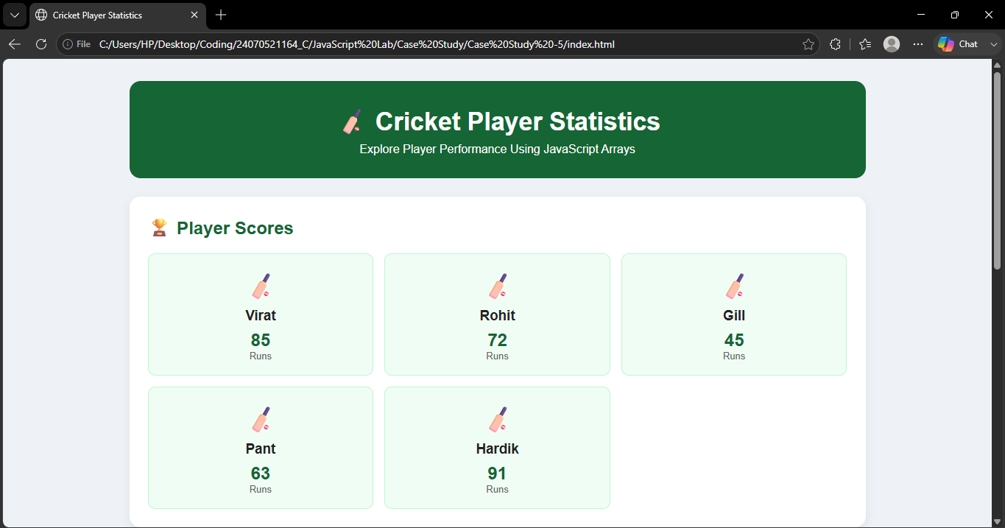

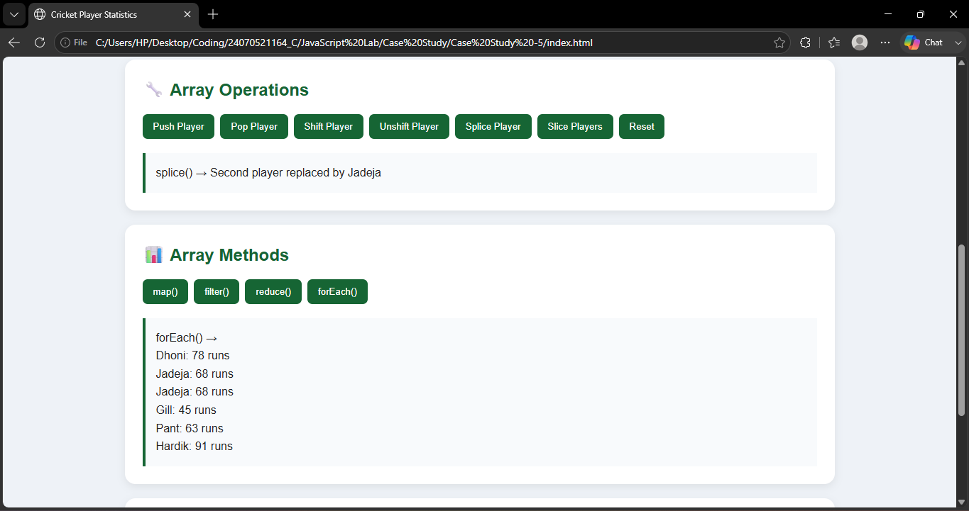

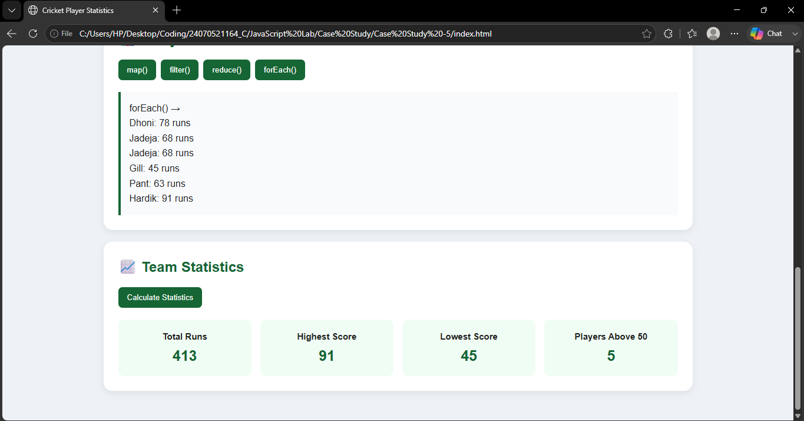

Result / Conclusion :-
The Cricket Player Statistics webpage was successfully developed using HTML, CSS, and JavaScript.
Different array operations such as push(), pop(), shift(), unshift(), splice(), and slice() were implemented.
Array methods like map(), filter(), reduce(), and forEach() were successfully demonstrated.
The program calculates the total runs, maximum score, minimum score, and players scoring above 50 runs.
The experiment provided practical understanding of arrays, loops, and array manipulation in JavaScript.

